9. Climate
9.1 Rainfall Records
Earlier this year, all the old rain gauge data from event cards were entered into a computer database. Unfortunately the regular measuring of rainfall around the atoll was neglected in the past. Very little usable data was collected between 1973 and 1998. In most cases the gauges were left unattended too long and were allowed to overflow. Accurate data has only been collected since 1999. Rainfall at the station was collected accurately between 1968 and 1984 and again between 1994 and 2003. Station precipitation records for the period 1985 to 1992 are not available. The 1993 data is unreliable as the gauge was left to overflow.
A complete account of available rainfall data for the station and other gauges around the atoll are presented in appendix 9.

The only period where all gauges were attended without fail (daily collections for the station and monthly collections for gauges around the atoll) is the period 1999-2003. Mean annual rainfall for this period was calculated and presented with 95% confidence intervals in figure 80. The only significant difference in mean annual rainfall was found between the gauges of Cinq Cases -groves and Anse Var on Picard. It appears as though a decreasing gradient in rainfall from the South East to the North West is apparent. However, it must be noted that this data lacks statistical significance.

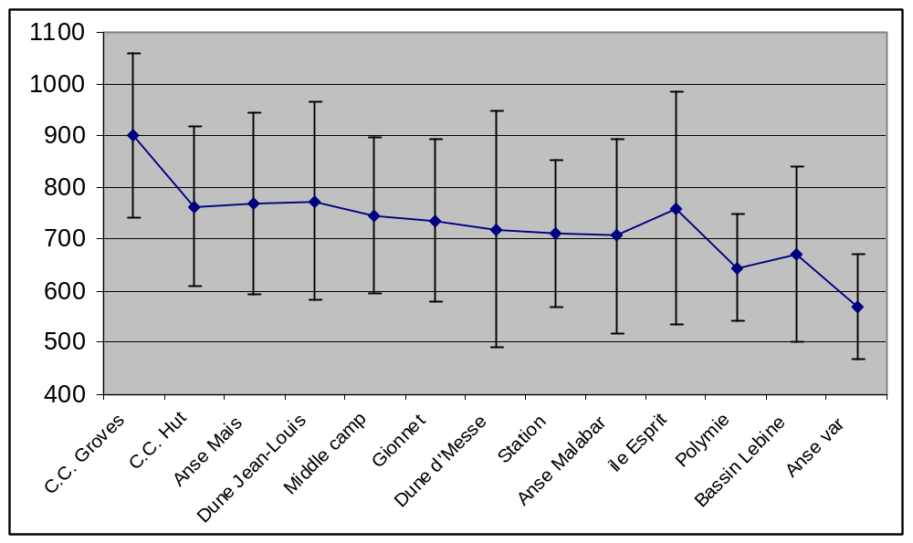
Figure 80: Mean annual rainfall between 1999 and 2003 with 95% Confidence intervals

The sum of all gauges per annum is displayed in figure 81. It is interesting to note that total rainfall in 2000 amounted to only half of the figure for 1999. It is quite clear that rainfall at Aldabra is highly variable. It must be noted that the month of December has not yet come to pass and has therefore not been included in the 2003 total.

Monthly rainfall over the last four years is depicted in figure 82. Peak monthly rainfall seems to vary between February and April.
It seems, in comparison to the past four years that we have had an average to above average year of rainfall. The month of April provided an unusually large percentage of the total rainfall (35%) (figure 83).

The highest amount of precipitation this year was recorded at the Cinq Cases –groves, followed by Dune d’Messe and Cinq Cases –hut. Lowest rainfall figures a were collected at Bassin Lebine and Anse Var on Picard (figure 84)

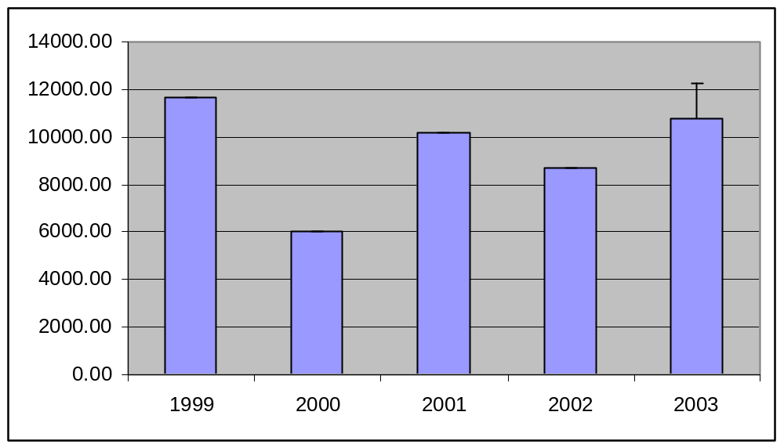
Figure 81: The sum of all rain gauge readings per annum
* Rainfall for December in 2003 not included.

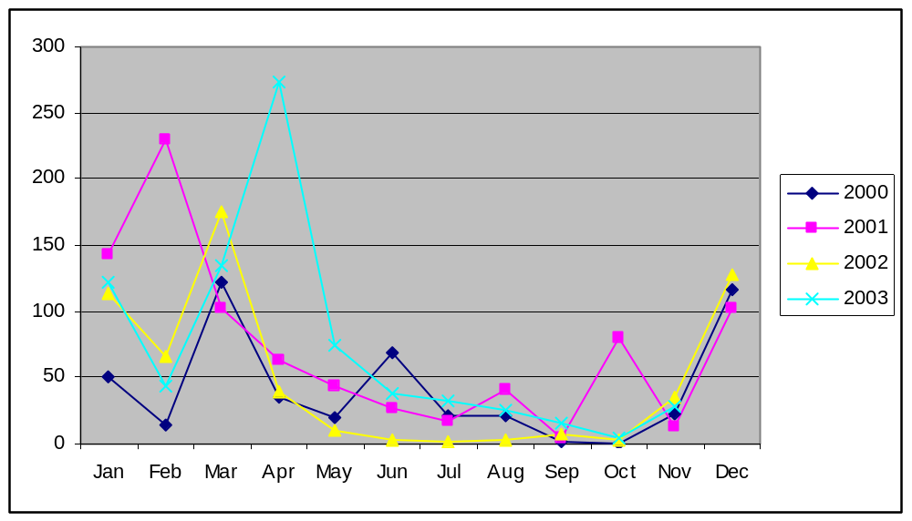
Figure 82: Total monthly rainfall for the years 2000-2003
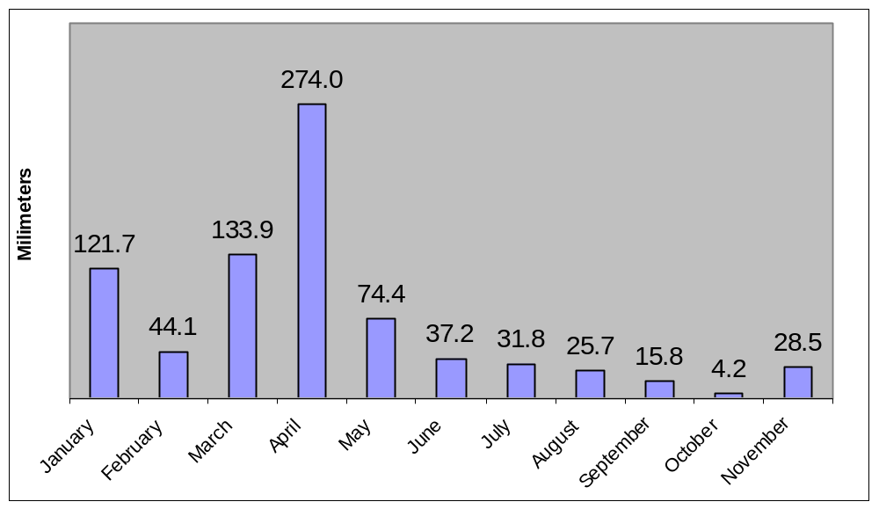
Figure 83: Monthly rainfall at the station between January and November 2003

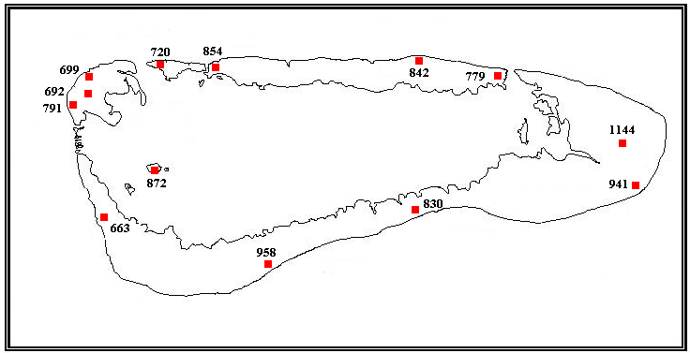
Figure 84: Rainfall around the atoll between January and November 2003

9.2 Meteorological records
Meteorological readings from the automatic weather station are presented in table 41. The wind speed recorder was replaced in September this year. Upon inspection, the old meter had a worn bearing which effectively decreased the speed of the recorder as the bearing became increasingly damaged. Apart from some minor power problems, the automatic weather station has functioned well this year.

Table 41: Meteorological readings for January to November 2003
Measurement | Jan | Feb | Mar | Apr | May | Jun | Jul | Aug | Sep | Oct | Nov
Mean Dry Bulb | 28.9 | 28.9 | 28.6 | 28.1 | 27.6 | 26.0 | 24.4 | 24.5 | 25.3 | 26.7 | 27.7
Mean Wet Bulb | 26.0 | 26.1 | 26.0 | 25.9 | 26.6 | 25.7 | 24.4 | 24.3 | 25.1 | 26.3 | 27.0
Mean Max C | 33.6 | 33.7 | 33.7 | 33.9 | 33.7 | 33.7 | 33.7 | 33.7 | 33.7 | 33.7 | 32.1
Mean wind (kn) | 4.3 | 3.3 | 2.3 | 2.8 | 3.7 | 4.5 | 4.2 | 5.2 | 5.6 | 6.0 | 4.8
Mean Max wind (kn) | 5.3 | 5.6 | 3.6 | 4.6 | 6.6 | 7.6 | 5.8 | 9.2 | 10.4 | 9.95 | 7.93
Total Rainfall (mm) | 121.7 | 44.1 | 133.9 | 274.0 | 74.4 | 37.2 | 31.8 | 25.7 | 15.8 | 4.2 | 28.5

Mean temperature peaked in January and February at 28.9ºC and lowest mean temperature was recorded in July at 24.4º (figure 85). Mean monthly temperatures for the period 2000 to 2003 are displayed in figure 86. A clear seasonal pattern is evident with a high in January / February and a low in July / August.

Mean annual temperature is depicted in figure 87. It is interesting to note that a slight but uniform (r²=0.94) increase in temperature has occurred since 2000.

Mean monthly wind speeds are illustrated in figure 88. Highest and lowest mean wind speeds were recorded in October and March respectively.
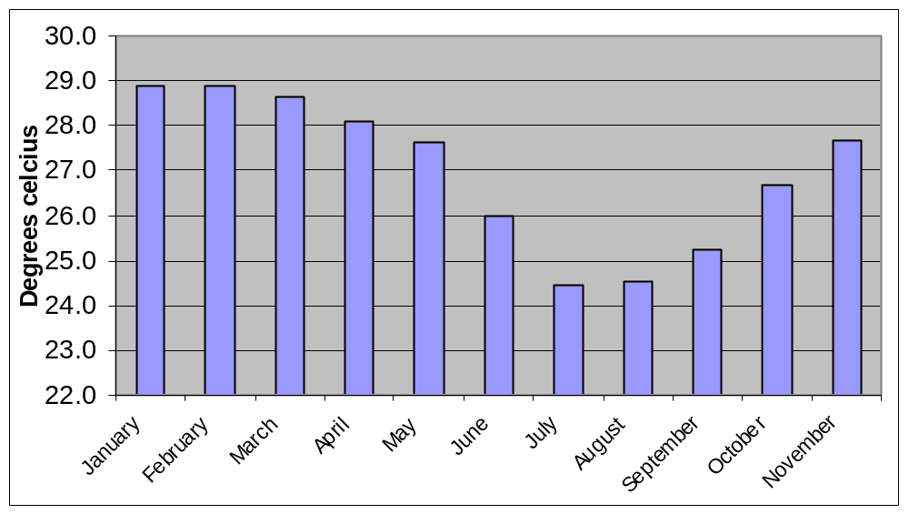
Figure 85: Mean dry bulb temperature from January to November 2003.

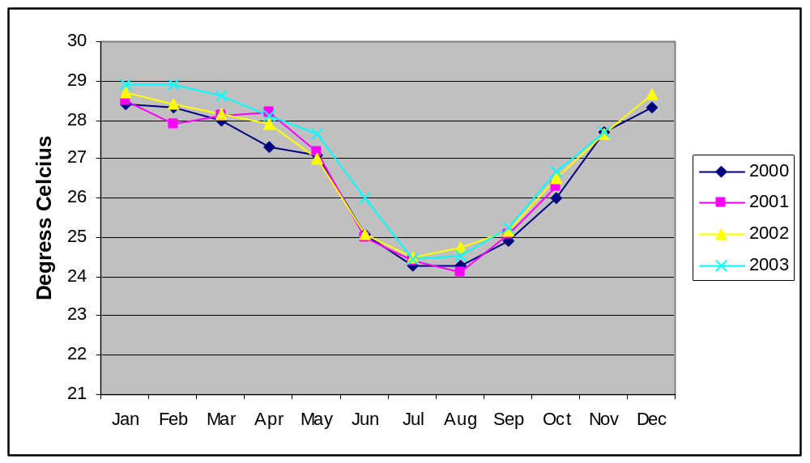
Figure 86: Mean monthly dry bulb temperature records for the period 2000 to 2003

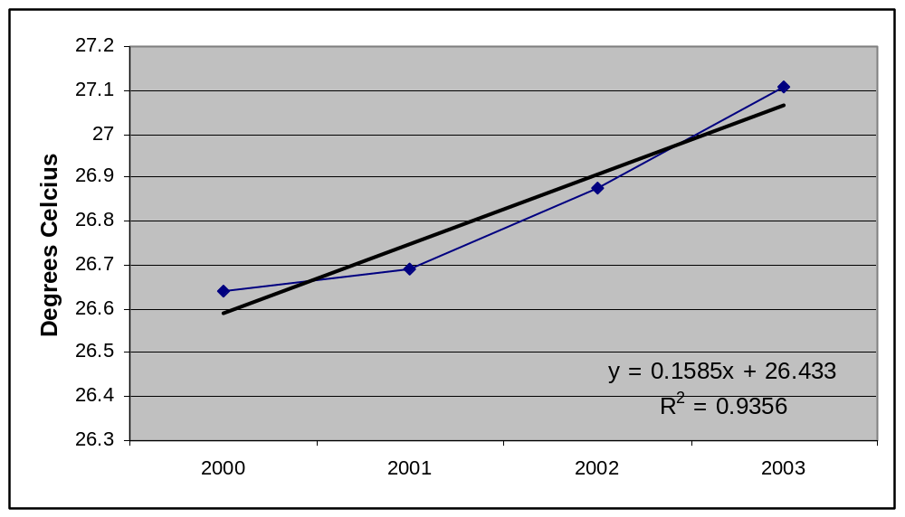
Figure 87: Mean annual dry bulb temperature for the period 2000 to 2003
* For the December 2003 value, mean annual temperature for that month was used.

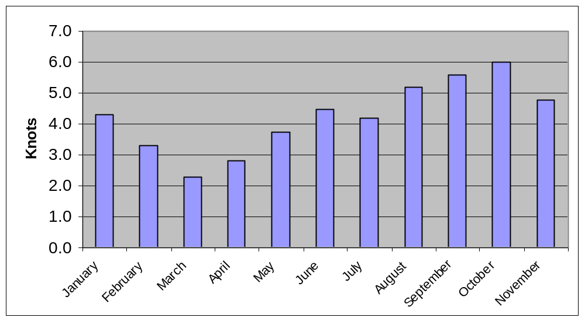
Figure 88: Mean monthly wind speed between January and November 2003.

